**1. CUSTOMER-PRODUCT RELATIONS**

Aim : write queries to create and retrieve customer and product relationship, DDL , DML command.

Table design

PRODUCT (product_no notnull varchar(15),description notnul lvarchar(15), company notnull varchar(15),price notnull int, primarykey product_no)

CUSTOMER (cust_no notnull varchar(15), name notnullvarchar(15), age notnull int,city notnull varchar(15), pincode notnull int, state notnullvarchar(15), primarykey cust_no)

SUPPLIER (s_no notnull varchar(10), sname notnullvarchar(15), age notnull int,city notnull varchar(15), primarykey sno)

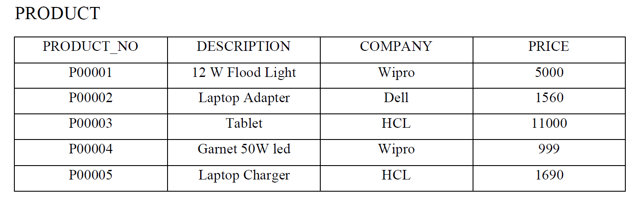

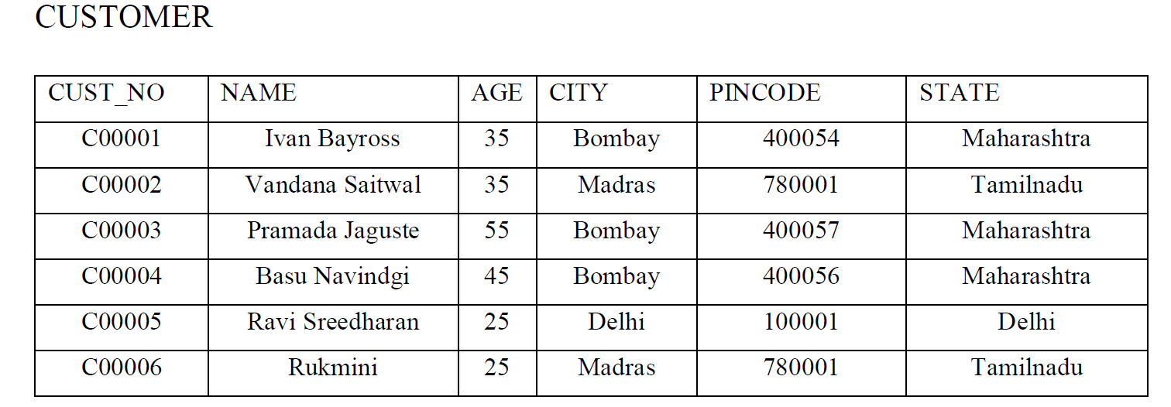

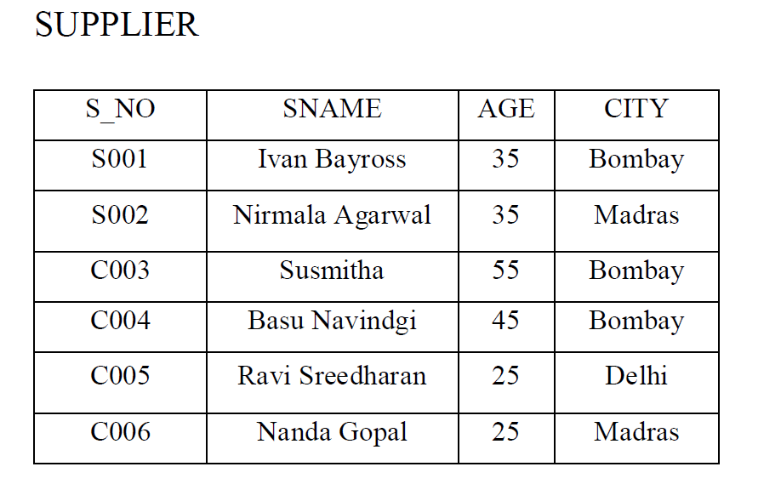

**Questions**

1. List all customers in Madras
2. List all the name of company whose price is greater than 5000?
3. Add email field into the customer table?
4. List all the customers whose age is greater than 40 in Maharashtra?
5. List cities of customers from states Maharashtra & Tamil Nadu.
6. Update product number of customer number C00003 to P00008.
7. Find the number of customers from city Delhi.
8. Delete the product with product no = P00003
9. Copy the contents of field order_no and orderdate of purchase table into new table.
10. Delete the newly created table.
11. Truncate the table